**Name: ……………………………………………. ADM NO: …………………………………..**

**Student’s signature: ……………………………. Date: ..…………….…………………………**

**FANAKA GIRLS HIGH SCHOOL**

**DECEMBER HOLYDAY ASSIGNMENT**

**MATHEMATICS**

**FORM 2**

**TIME: 2 HOURS**

**INSTRUCTIONS TO CANDIDATES**

* Write your name and index number in the spaces provided above.
* Answer ALL the questions in the spaces provided in the question paper.

1. Evaluate

$\frac{\left(1\frac{3}{7}-\frac{5}{8}\right)×\frac{2}{3}}{\frac{3}{4}+1\frac{5}{7}-\frac{4}{7} of 2\frac{1}{3}}$ (3mks)

1. A fruit juice dealer sells the juice in packets of 300ml,500ml and 750ml ,find the size of the smallest container that can fill each of the packets and leave a remainder of 200mls (3mks)
2. Use tables to evaluate $\frac{415.2×0.0761}{135}$ (3mks)
3. A line L1 is parallel to a line whose equation is 3y $-$ 6x +7=0 and passes through the point (3,5). Find the equation of L1 (3mks)
4. Form the quadratic equation whose roots are

X= $-3$ and x=1 (3mks)

1. Find the area of the following triangle

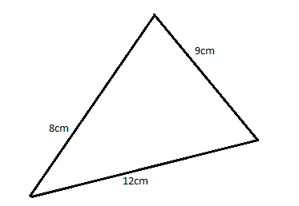

1. Given that cos x= sin (3x+10) find x (3mks)
2. Expand (x +5)(3x +2) (3mks)
3. You are given that cos x= $\frac{8}{10}$ find for the value of Sin x (3mks)
4. Solve the simultaneous equations

3x $-$ ­2y =7

5x+3y=3 (3mks)

1. Solve the equation

X254=0 (3mks)

1. Given that the lengths of three sides of a right angled triangle are x,(x+1) and (x+2) units , find the value of x

(3mks)

1. Find the surface area of the following pyramid with slanting height edge of 8 and a square base 4cm (4mks)

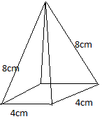

1. The initial velocity of a car 10m/s. the velocity of the car 4 seconds is 30m/s. find its acceleration (3mks)
2. A man is 24 years older than his son.After 10years he will be three times as old as his son. How old is the son ?

(3mks)

1. From a balcony 16m above the ground an observer notices that the angle of depression 0f the foot of a multi- storeyed building is 18.6°. The angle of elevation of the same building from the balcony is observed to be 50.5°. Calculate to the nearest metre the height of the building (4mks)
2. A truck left Nyeri 8:00a.m for Nairobi at an average speed of 60km/h. At 9:00 am , a bus left Nairobi for Nyeri at a speed of 120km/h. The distance between Nyeri and Nairobi is 160km. find:
3. How far from from Nyeri did the vehicles meet (7mks)
4. The time of the day the vehicles met (3mks).
5. The heights of a number of students were recorded in the table below. Each measurements is

given to the nearest cm.

|  |  |  |  |
| --- | --- | --- | --- |
| Height | Class mid-point (x) | Frequency (f) | Fx |
| 138 $-$ 142 | 140 | 3 | 420 |
| 143-147 |  | 8 |  |
| 148-152 |  | 12 |  |
| 153-157 |  | 20 |  |
| 158-162 | 160 | 30 | 4800 |
| 163-167 |  | 14 |  |
| 168-172 |  | 7 |  |
| 173-177 |  | 4 |  |
| 178-182 | 180 | 2 | 360 |
|  |  | $$\sum{f=}$$ | $$\sum{fx=}$$ |

1. Complete the table above (4mks)
2. State the modal class (1mks)
3. Use the completed table to calculate the mean height of the student (2mks)
4. Calculate the median height (3mks)
5. Solve the inequalities
6. $\frac{1}{4} x-\frac{1}{2}>\frac{1}{3}x-\frac{2}{3}$ (3mks)

$3x+4≥-2$

5x $-11<4$ (3mks)

1. By drawing appropriate straight lines and shading the unwanted region ,illustrate on graph paper the region which satisfies all the inequalities below :

2y+5x $≥10$

2y $-$ x $>2$

y $≤5$ (4mks)

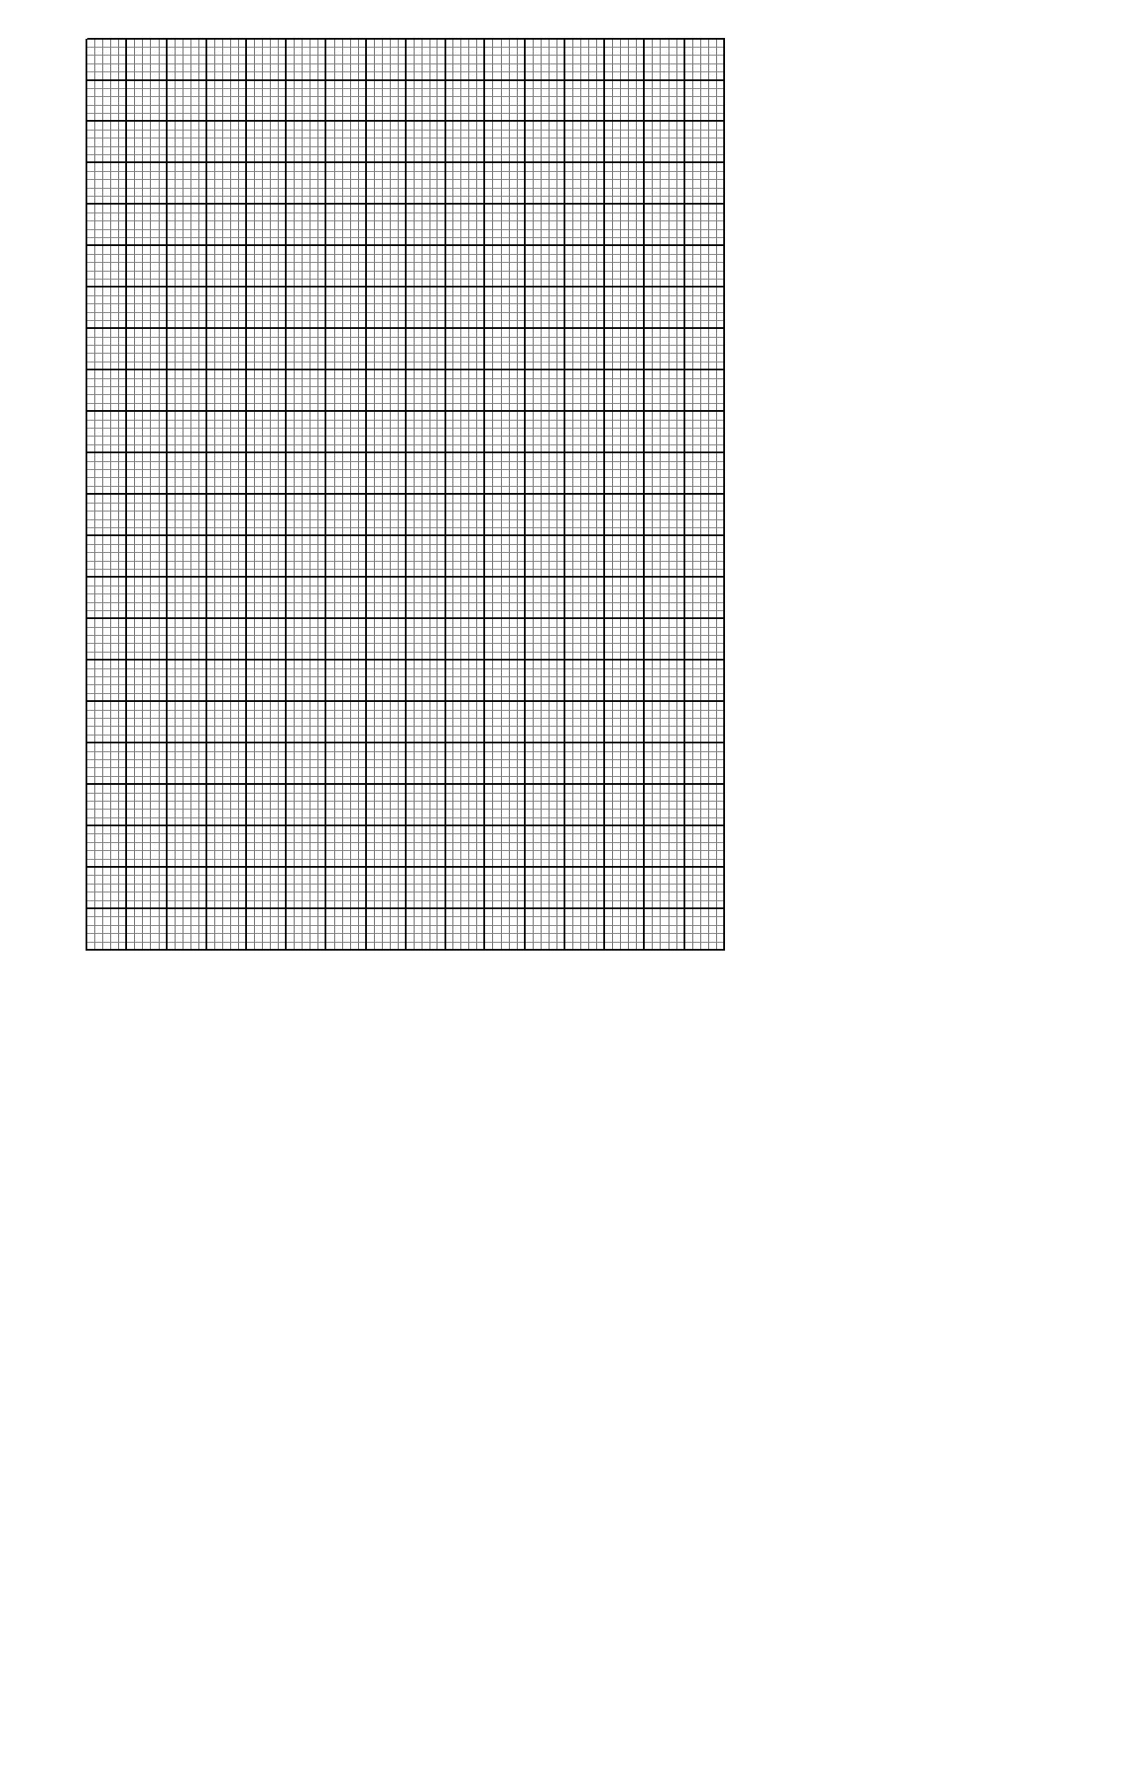

1. Two intersecting circles are such that the circles have their radii 18cm and 12 cm respectively and the chord AB is 18cm long .

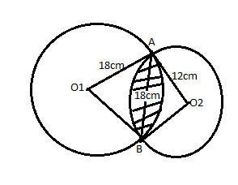

1. Find angle AO1B (3mks)
2. Find angle AO2B (2mks)
3. Find the area of the shaded part (5mks)
4. A bucket is 42cm in diameter at the top and 28cm in diameter at the bottom. find its capacity in litres if it is 36cm deep (10mks)

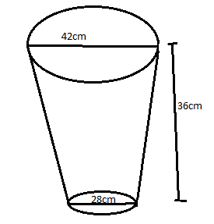

1. A sector of a circle of radius 42cm subtends an angle of 120° at the centre of the circle .
2. Calculate :
3. The area of the area sector (2mks)
4. The length of the arc (2mks)
5. The sector is folded to form a cone. Calculate
6. The radius of the cone (2mks)
7. The vertical height of the cone to one decimal place (2mks)
8. Determine the capacity of the cone litres to 2 d.p (2mks)
9. A chord AB of length 12cm is drawn in a circle with centre O and radius 10cm calculate

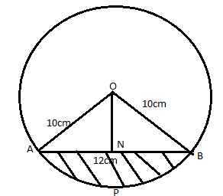

1. the distance ON (2mks)
2. The area of the sector OAPB (4mks)
3. The area of the triangle OAB (2mks)
4. The area of the shaded part (2mks)
5. The data below shows marks obtained by 20 student in a composition

5,5,9,4,5,3,5,11,6,3,6,8,9,6,13,8,8,13,5,10.

1. Prepare a frequency distribution table (5mks)
2. Find the mean of the above data (2mks)
3. Solve the following simultaneous equation and illustrate your answer on a number line.

2x+3 $>$ 5x $-3>-8$ (3mks)